Smart Change Journal
Developed by Art Markman, PhD

Get yourself a blank journal and respond to the prompts and questions on the following pages or use this document to create your own Smart Change Journal. Guided by your own observations, along with the advice that I offer in the book Smart Change (Perigee Books), you will be able to more effectively develop a plan to achieve your goals and realize your ultimate contribution. I have highlighted the respective chapters from the book related to these prompts at the top of each page.

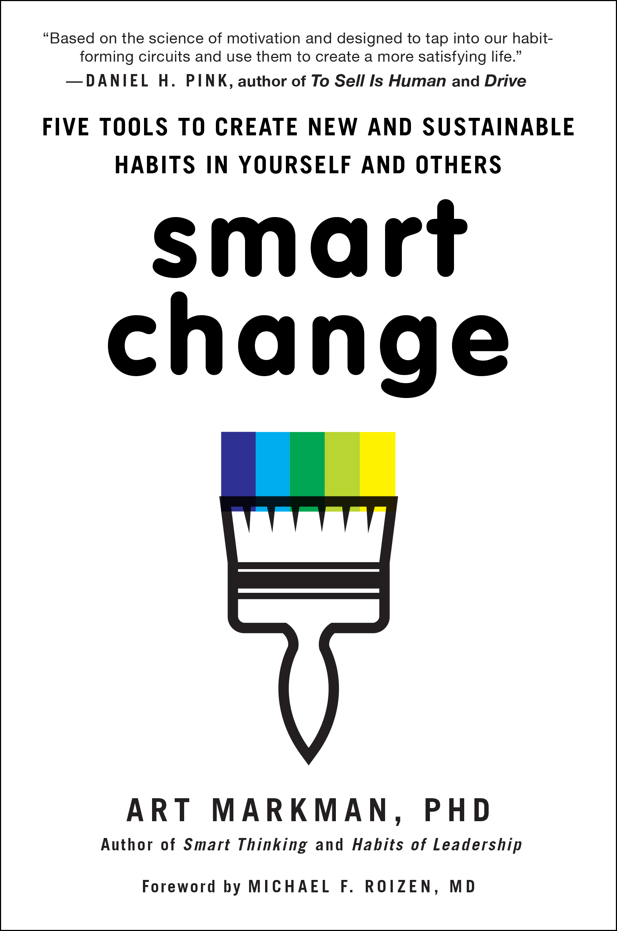

The Big Picture

(Chapter Three: Optimize Your Goals)

What do you want accomplish?
Why is this goal important?
Are you really sure this is the right goal? Why?

Be Specific

(Chapter Three: Optimize Your Goals)
On a new page in your journal, create three lists: The actions you can take to advance you toward your goal; identify the obstacles that you may face when you take these actions; and what are the signs that you have succeeded at the specific actions. (See Chapter 3 to review the three aspects of these signs.)
Actions Obstacles Signs

How can you fit new actions into your life?

(Chapter Four: Tame the Go System)
Engage in a fantasy to think about how the new actions will fit into your life. Based on that fantasy, you need to develop a specific plan for how to incorporate those new actions into your life. As part of this plan, you need to decide what you are going to do, when and where you will do it, and the people you will need to engage in these actions.
Respond to the follow questions for each action you determine to take.

What action are you going to take?

When are you going to do it?

Where will this take place?

How often are you going to need to perform this action?

What aspects of your life will you need to work around to reach my goal?

Whose help do you need?

What resources do you require?

Changes to Your Environment
(Chapter Six: Manage Your Environment)

Draw pictures or describe the key environments related to the changes you want to make: home, office, social club, etc.

What adjustments can you make to your environment to help the changes you want to make become habits?

What changes can you make that will disrupt old habits?

Dealing with others who share your environment?

Who are the people in your home environment?

Who are the people in your work environment?

What other people share your environments?

For each environment, explore how to minimize the disruption of the environment for those people while still supporting your behavior change efforts.

Family, Strangers, Neighbors, and Others

(Chapter Seven: Engage with People)

Family: How can (should) they be involved in your behavior change?

Strangers: Because we tend to be victims of goal contagion identify the “Good Strangers” and the “Bad Strangers” who will have an influence for the better or worse on your behavior – and in your progress toward your ultimate goal.
Good Strangers Bad Strangers

Neighbors: Who are the members of your community with whom you engage? How can your neighbors help you avoid temptation?

Mentors: Who are your potential guides and counselors? How can you engage them?

Partners: Who are the people who can share this journey with you? How can you engage them?

14-Day Habit Diary

(Chapter Seven: Engage with People)

The more you understand about the pattern of your activities, the better able you will be to make changes that bring you into contact with people who will support the goals you want to achieve.

For the next two weeks at the end of each day respond to the following questions to keep track of your movements and the people with whom you engaged.

Date:
Where did I go?
Did the places I go make it harder for me keep on track with my goals?
Who helped make change easier, or harder?
What other factors made change easy or difficult?

Tracking Your Progress
(Chapter Eight: Making Change)

Now that you’ve done the preliminary work, you need to start tracking your progress. Your Smart Change Journal can help. From this point forward, your Smart Change Journal becomes a record of your successes and failures.
At the end of each day, turn to a new page in your journal and take a couple of minutes to write down how your efforts at change are going.

Date:
What were my big successes?
What were the big temptations?
What could I have done better?

